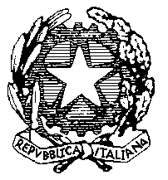
Ministero della Pubblica Istruzione

FONOGRAMMA IN PARTENZA/ARRIVO

Prot. n. _________ Data _______________ Ora ______

Provenienza __________________________________

Destinazione __________________________________

Oggetto ______________________________________

Trasmette ______________________ Riceve ___________________

Testo ___________________________________________________
___________________________________________________
___________________________________________________
___________________________________________________
___________________________________________________

IL DOCENTE

________________________

IL DIRIGENTE SCOLASTICO
___________________________________

